Capitalism Enslaves Wombs
The recent abortion ban is not an isolated outrage. It is a symptom of bigger, deeper problems in our culture.
Womb slavery is not like chattel slavery and wage slavery, which enrich plutocrats directly. Rather, womb slavery is like racism and Islamophobia, which create fear, hardship, and division among working people. Those conditions help to perpetuate the plutocracy, as I will explain.
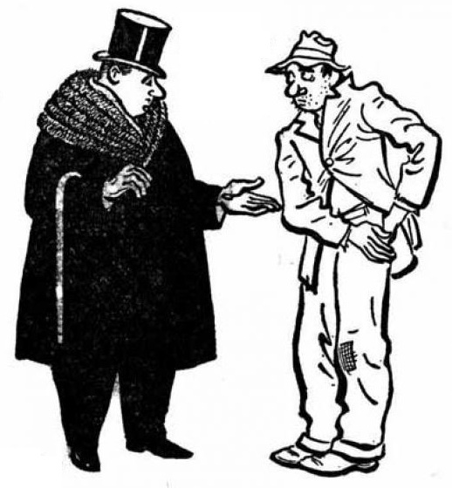
If we don’t share, we must trade – for labor, food, rent, interest, influence – for everything. Trade brings greater profit to whichever trader is already in the stronger bargaining position, thus making him stronger still. Thus, even when honest, trade increases inequality, which is now huge. Bosses and landlords get rich; workers and tenants stay poor. Money is influence, so government favors the rich, regardless of elections; Gilens and Page demonstrated that statistically. The USA has been a plutocracy thinly disguised as a democracy ever since its origin in land theft, genocide, slavery, and indentured servitude.
Power corrupts, as we see in workplace bullying, prison torture, killer cops, and wars based on lies to make a few rich men richer. Capitalism is cruel: The rich persuade themselves that they deserve their wealth and that the poor deserve their poverty, and that in fact the poor should be punished for laziness. Our workplaces are dictatorships that objectify, exploit, and discard us; we all end up objectifying each other. Low wages and difficult working conditions exhaust us, so we have little time and energy for thinking about rebellion and change.
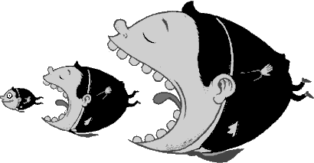
Competition kills empathy, leaving fear, hate, lies, authoritarianism, madness, random shootings. We are stratified by our different incomes and other distinctions. We are encouraged to malign immigrants, refugees, the poor, anyone who looks or lives differently from us, anyone who is weaker and cannot fight back, anyone other than our rulers themselves. Divided, we cannot rebel.
Our “every man for himself” culture puts short-term private profit ahead of all else. That is why the ecosystem is being destroyed and we’re on the verge of extinction.
To ban abortion is to imprison women, to deny them control over their own bodies. This makes objects of women and robs them of agency. That, in turn, objectifies and robs men too, for we can only be free together. Any sort of discrimination (against women, blacks, Muslims, etc.), when enforced or even tolerated by the state, perpetuates unquestioning obedience to tradition. Theocracy makes rebellion unthinkable.
The first step in fixing all these problems is seeing how they are connected. Join the discussion.  10/1/21  Links at https://LeftyMathProf.wordpress.com/abort

